# Project Synopsis

Submitted By: - Marmik Parashar, Shashwat Mishra, Vansh Sachdeva and Ayushi Dadhich

## Problem Statement

For efficient energy management, resource planning, and  support of sustainability programs, forecasting of electrical energy consumption  is essential. The complex and dynamic nature of modern energy systems is often overlooked by conventional forecasting methods, such as statistical and econometric models. These approaches struggle to accommodate sudden changes in energy consumption, which can be caused by global disasters such as the COVID-19 pandemic, weather variability, and economic changes.

Forecasting energy demand is also becoming more challenging due to the integration of renewable energy, fuel price volatility, and rapid urbanization. Inaccurate forecasts can lead to wasted resources, misallocation of energy, and failure to meet environmental goals.

## Introduction

Machine learning techniques have become highly effective tools for analyzing large data sets and finding complex patterns in energy consumption data. However, further research is still needed to fully understand the performance and applicability of these models in different market scenarios, such as volatile or stable periods. This work aims to fill these gaps by using machine learning methods to increase the accuracy and flexibility of electric energy consumption forecasting.

Infrastructure planning

ng, environmental sustainability, and economic development are all significantly affected by energy consumption. It is more important than ever to accurately predict electrical energy consumption due to the increasing global energy demand and the complexity of energy infrastructure. To do this, traditional techniques such as econometric and statistical modeling have been widely used. However, these methods often fail to capture the complex non-linear correlations present in energy consumption data and cannot adapt to rapidly changing market conditions.

By using advanced algorithms to examine large datasets and find hidden patterns, machine learning (ML) offers a viable alternative. Machine learning methods such as Random Forests, XGBoost, ARIMA, and SARIMA can improve the accuracy and flexibility of energy consumption forecasts. These models perform particularly well when processing.

## Hardware and Software Specification Requirements

**Hardware:**

1. Processor: Intel i7 (8th Gen) or AMD Ryzen 7
2. RAM: 12GB DDR4
3. Storage: 100GB SSD
4. GPU: WhiskeyLake-U GT2 [UHD Graphics 620]

**Software:**

1. OS: Linux, Windows 11 Home
2. Text Editors: VSCode, Anaconda Jupyter
3. Data Visualization: Power BI, Spreadsheet Viewer
4. Browser: Google Chrome or compatible browser

## Data Flow Diagram

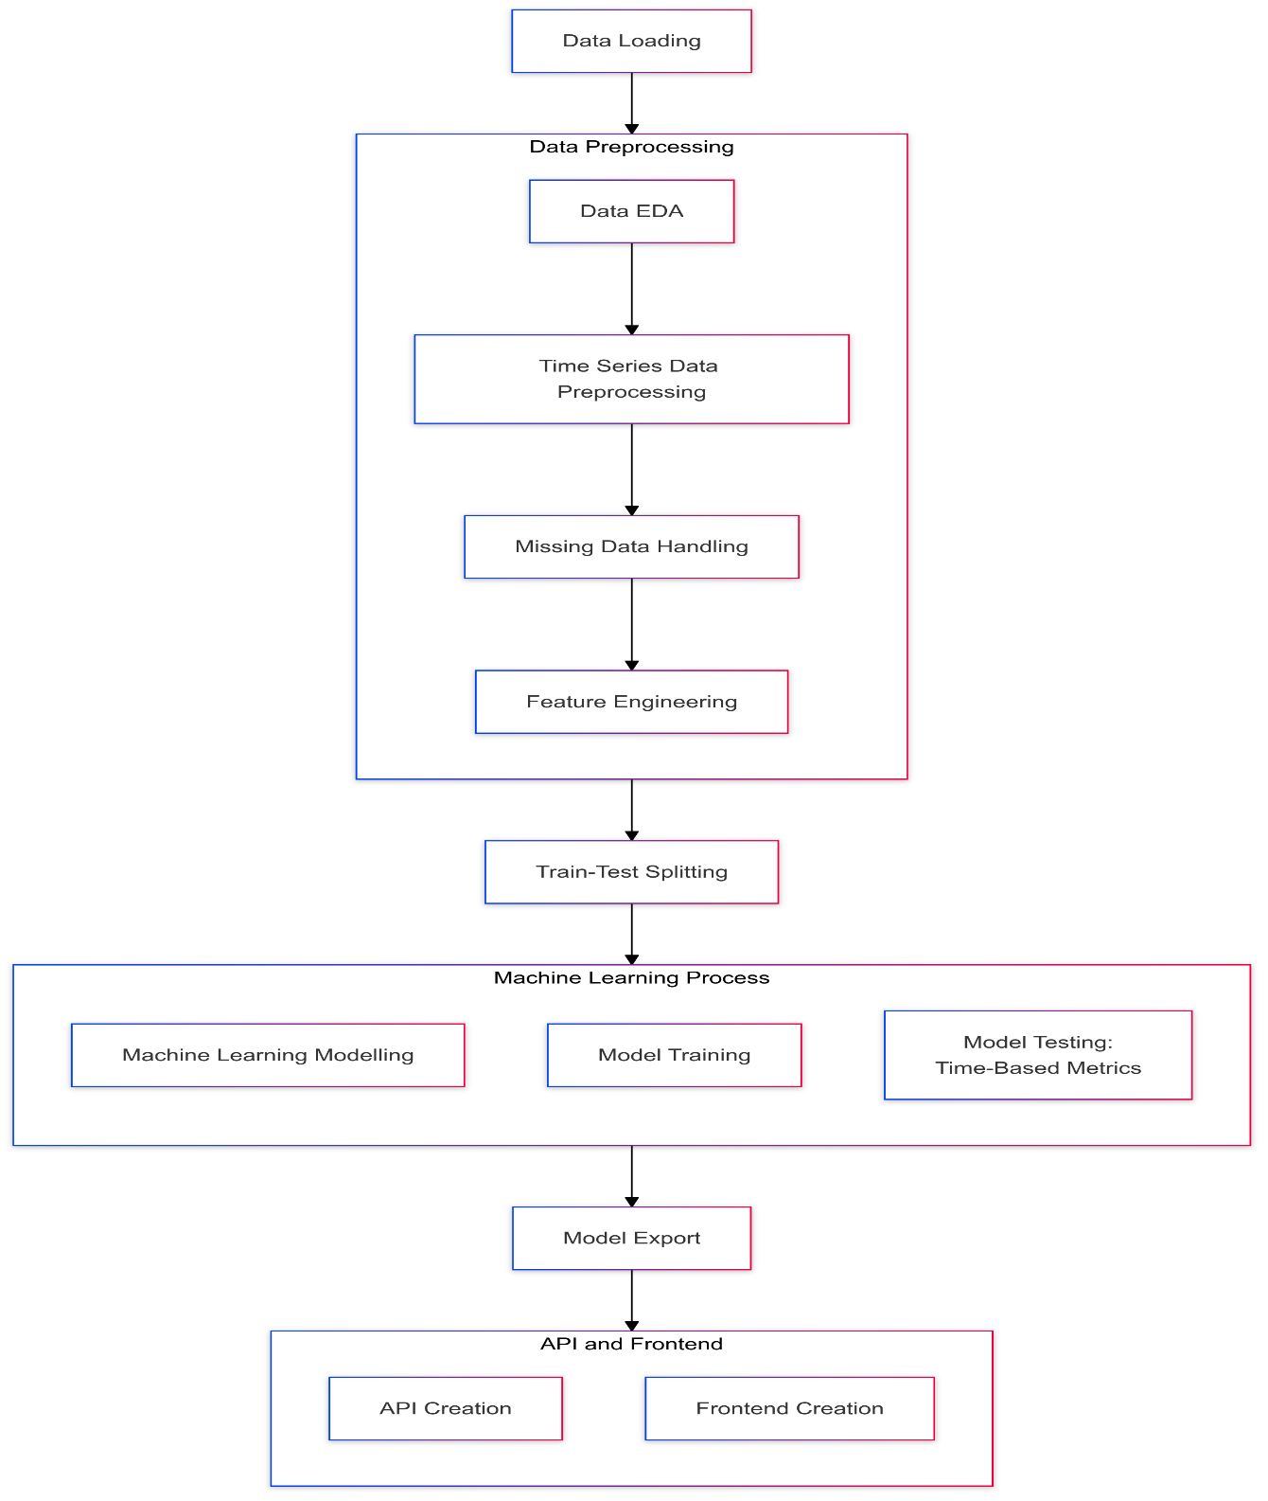

1. **Technical Demonstration**

## Libraries Used

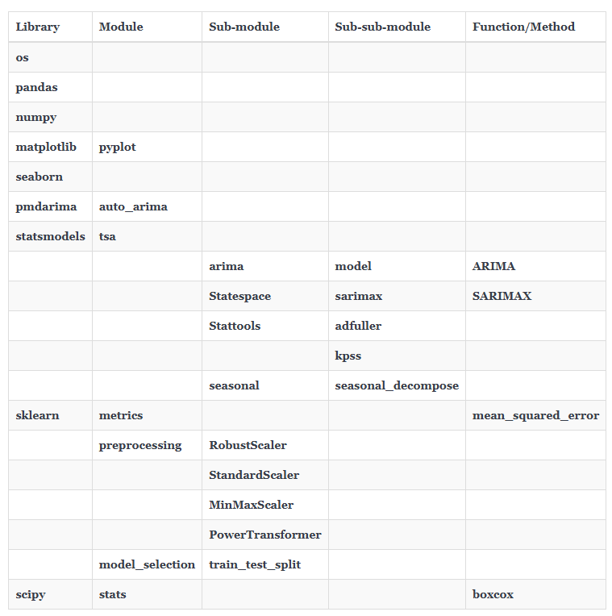

## Deployment

Not applicable

## Advantages

1. **Improved Forecast Accuracy:-**

Compared to conventional techniques, machine learning models such as Random Forests, XGBoost, and LSTM can examine complex and non-linear correlations in energy data to provide more accurate forecasts.

1. **Integrating multiple data sources:-**

To provide a holistic approach to energy forecasting, machine learning enables the integration of multiple types of data, including historical consumption records, weather data, economic indicators, and population patterns.

1. **Improved decision making:-**

Accurate forecasting enables more efficient use of resources, reduces energy waste and ensures a stable balance between supply and demand. This facilitates efficient planning of energy production, distribution and use.

1. **Supporting Sustainable Development Goals:-**

Machine learning-based forecasting helps achieve environmental goals, including reducing greenhouse gas emissions and encouraging the use of sustainable renewable energy sources by optimizing energy consumption and minimizing reliance on inefficient resources.

## Application Scope for Energy Consumption Prediction

**Residential**

* Personalized energy saving recommendations.
* Real-time consumption monitoring for households.

**Industry**

* Optimizing machine operations to reduce consumption during peak hours.
* Predicting maintenance schedules based on energy trends.

**Government and public services**

* Planning infrastructure to meet future energy needs.
* Develop sustainable energy policies.

**Renewable energy sector**

* Efficiently integrate solar, wind and other renewable energy into the grid.
* Improve the use of energy storage by forecasting demand.

## Conclusion

Machine learning techniques can be utilized to improve energy consumption forecasting beyond traditional methods, as demonstrated in the project. Improved forecasting accuracy, scalability, and adaptability are achieved through the use of advanced algorithms such as Random Forests, SARIMA and ARIMA. These techniques enable energy management. By integrating various data sources and analyzing complex patterns, the proposed model facilitates informed decision-making, sustainable resource use, and support of environmental goals. The focus of this project is on the application of machine learning to optimize energy consumption, reduce waste, and promote a sustainable energy ecosystem for better infrastructure planning and sustainability.

## Reference

Kumari, S. and Singh, S.K. (2022). Machine learning-based time series models for effective CO2 emission prediction in India. *Environmental Science and Pollution Research*. doi:https://doi.org/10.1007/s11356-022-21723-8.

Shin, S.-Y. and Woo, H.-G. (2022). Energy Consumption Forecasting in Korea Using Machine Learning Algorithms. *Energies*, 15(13), p.4880. doi:https://doi.org/10.3390/en15134880.

Yan, P., Abdulkadir, A., Luley, P.-P., Rosenthal, M., Schatte, G.A., Grewe, B.F. and Stadelmann, T. (2024). A Comprehensive Survey of Deep Transfer Learning for Anomaly Detection in Industrial Time Series: Methods, Applications, and Directions. *IEEE access*, pp.1–1. doi:https://doi.org/10.1109/access.2023.3349132.